GitHub Repository Screenshot before any changes:

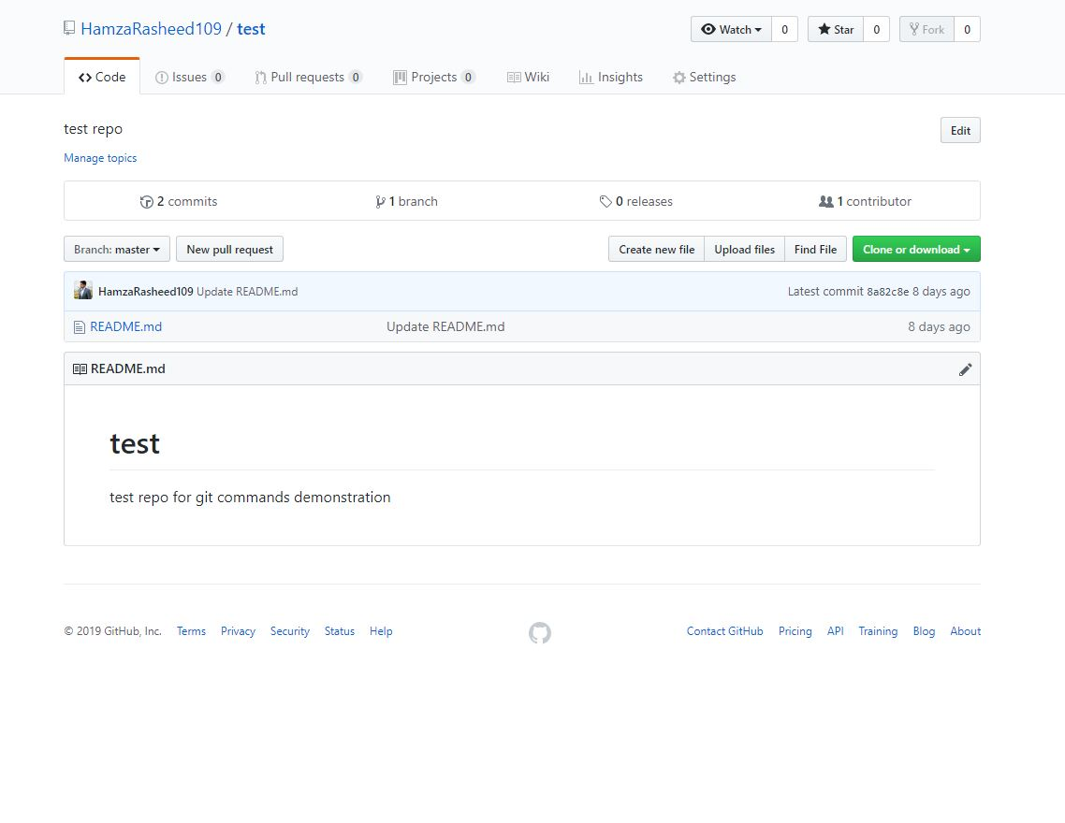

Initial Git status:

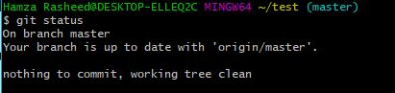

After adding one file into the local directory:

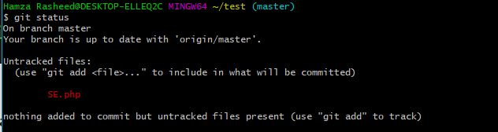

After adding file to staging area:

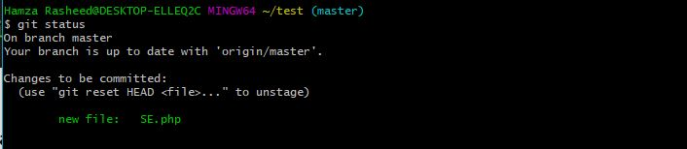

After committing the file in staging area:

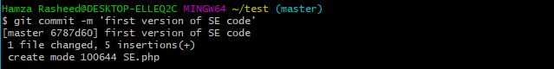

Gitlog:

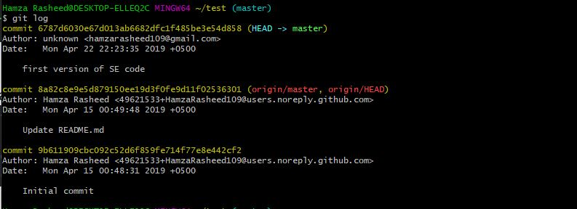

Git Status after committing:

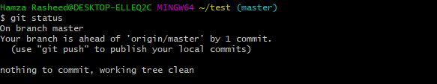

Git push:

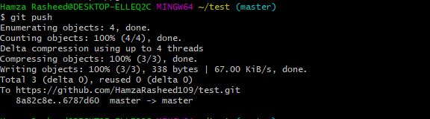

GitHub Screenshot after pushing changes:

